A000-ME-Mesopotamia-Lagash-Sumerian Culture-Foundation Cone-2140 BCE  
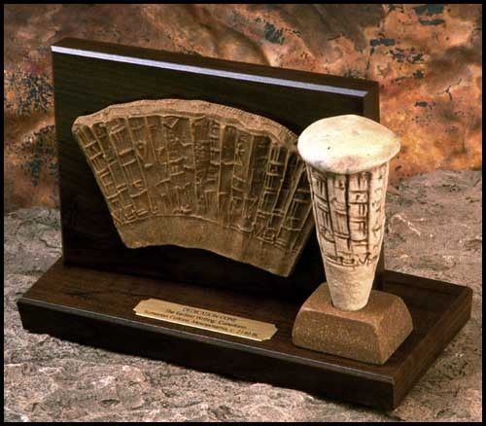

Mesopotamia-Lagash-Sumerian Culture-Foundation Cone-2140 BCE

**Case No.: 2**

**Accession No.:**

**Formal Label:** Mesopotamia-Lagash-Sumerian Culture-Foundation Cone-2140 BCE

**Display Description:**

This cuneiform cone was used to dedicate a building in Lagash, Sumeria, in 2140 BCE. This cone named the ruler, Gudea, who was responsible for the building and requested the blessings of the gods in its use. It was a message placed in the building's cornerstone, a testimony to a great accomplishment, to achieving something important and of lasting value, and which invoked the protection of the ancient Sumerian gods on the endeavor and acknowledges pride in creating a worthy and lasting accomplishment - "let the gods take notice!"m The cone was never intended to be seen by human eyes again.

Transliteration  
1.   For (the) god Ningirsu   
2.   mighty warrior   
3.   of (the) god Enlil,   
4.   Gudea,   
5.   ruler   
6.   .... (obscured - probably an official attribute like 'the steadfast' or 'righteous shepherd')   
7.   of Lagash   
8.   The White Thunderbird Temple   
9.   built (and)   
10. ....(obscured - something like 'restored it to it's place) 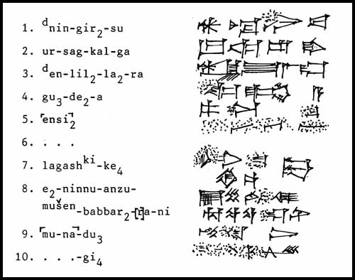

**LC Classification:**

**Date or Time Horizon:**

**Geographical Area:**

**Map:**

**GPS coordinates:**

**Cultural Affiliation:**

**Medium:** original, terra cotta

**Dimensions:** 4 1/4" x 2" dia. (at base)

**Weight:**

**Condition: resin replica**

**Provenance:**

**Discussion:**

**References:**